#### **Project Overview**

**Objective:**

* This capstone project is designed to reinforce your understanding of Data Pipeline Orchestration with Apache Airflow. The focus is on implementing a data pipeline that addresses data ingestion, processing, storage, and analysis. The project challenges you to apply your knowledge of Apache Airflow to solve a practical scenario based problem.

**Duration:**

* 1 week (To be submitted on Saturday 19th of October, 2024)

**Deliverables:**

* A data pipeline orchestrated with Apache Airflow
* Documentation of the design or architecture of the data pipeline, including the rationale behind key decisions and useful information.

**Mode of Submission:**

* A link to a Github repo containing your solution to be submitted using this form:

<https://forms.gle/oTEmmoCJPYpXxAte7>

#### **Project Scenario**

**Background:**

* You have been hired by a data consulting organization, who is looking at building a stock market prediction tool that applies sentiment analysis, called **CoreSentiment.** To perform this sentiment analysis, they plan to leverage the data about the number of Wikipedia page views a company has.Wikipedia is one the largest public information resources on the internet. Besides the wiki pages, other items such as website pageview counts are also publicly available. To make things simple, they assume that an increase in a company’s website page views shows a positive sentiment, and the company’s stock is likely to increase. On the other hand, a decrease in pageviews tells us a loss in interest, and the stock price is likely to decrease.

**Data Source:**

Luckily the needed data to perform this sentiment analysis is readily available. The Wikimedia Foundation (the organization behind Wikipedia) provides all pageviews since 2015 in machine-readable format. The pageviews can be downloaded in **gzip** format and are aggregated per hour per page. Each hourly dump is approximately 50 MB in gzipped text files and is somewhere between 200 and 250 MB in size unzipped.

The pageviews data for October, 2024 can be found here <https://dumps.wikimedia.org/other/pageviews>

The structure and technical details of Wikipedia pageviews data is documented here: [structure](https://meta.wikimedia.org/wiki/Research:Page_view) and [technical details](https://wikitech.wikimedia.org/wiki/Analytics/Data_Lake/Traffic/Pageviews).

**Sample Data Explanation:**

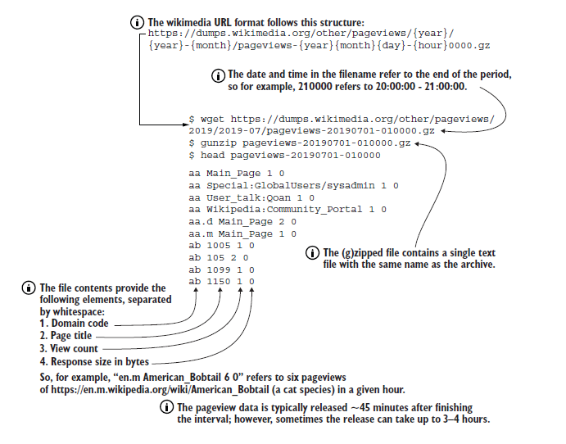

**Project Tasks:**

To start small, your manager has asked you to create the first version of a DAG pulling the Wikipedia pageview counts by downloading, extracting, and reading the pageview data for any one hour duration on any date in October 2024 (**e.g 4pm data for 10th of October, 2024**). To further streamline your analysis, you have been asked to select just five companies (**Amazon, Apple, Facebook, Google, and Microsoft**) from the data extracted in order to initially track and validate the hypothesis.

**Requirements:**

In order to support you, your manager has created the following Algorithm for accomplishing your tasks.

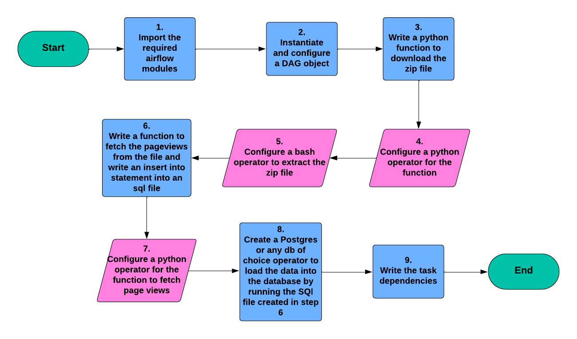

You can follow these steps to complete your Airflow DAG development. **Note:** It is just a guide to help you but it is not mandatory to follow the steps. Feel free to accomplish the tasks using any suitable approach you prefer.

When you are done with the DAG development and you have successfully loaded the data into a database by running your data pipeline, then perform a simple analysis to show which company’s page out of the 5 selected has the highest views (You can write a simple SQL query to achieve this).

**Tasks Summary**Download and extract the zip file containing the pageviews data for just one hour, fetch the needed fields and pagenames only, load the fetched data into a database of your choice and do a simple analysis to get the company with the highest pageviews for that hour.

### **Conclusion**

By accomplishing this case study project, you will become more confident in your data pipeline orchestration with Apache Airflow skill. Give it your best shot and learn as much as possible along the process. Ask as many questions as needed and make Google your best friend. I wish you best of luck.